CSA1708-ARTIFICIAL INTELLIGENCE
LAB EXPERIMENTS
Program 31 : Create a Web Blog Using WordPress
Aim
To create a WordPress blog page that demonstrates the HTML title tag and anchor tags.
Algorithm
1. Create or open a WordPress site and add a new page.
2. Set the page title to AI Learning Blog; the active theme generates the browser title tag.
3. Add a Custom HTML block and enter the blog markup below.
4. Publish the page and test each navigation link.
Program
In WordPress, the page title is used by the theme for the browser tab title. Add this body markup in a Custom HTML block:
WordPress-generated title tag (example):
<title>AI Learning Blog</title>
<h1 id="top">AI Learning Blog</h1>
<nav>
<a href="#about">About</a> |
<a href="#posts">Posts</a> |
<a href="https://wordpress.org/">WordPress</a>
</nav>
<section id="about">
<h2>About</h2>
<p>Notes from the Artificial Intelligence lab.</p>
</section>
<section id="posts">
<h2>Latest Posts</h2>
<p>Welcome to my AI learning blog.</p>
</section>
<a href="#top">Back to top</a>
Sample Output
The browser tab shows AI Learning Blog (the theme may add the site name). The About and Posts links jump to their sections, and Back to top returns to the heading.
Program 31 source and sample output
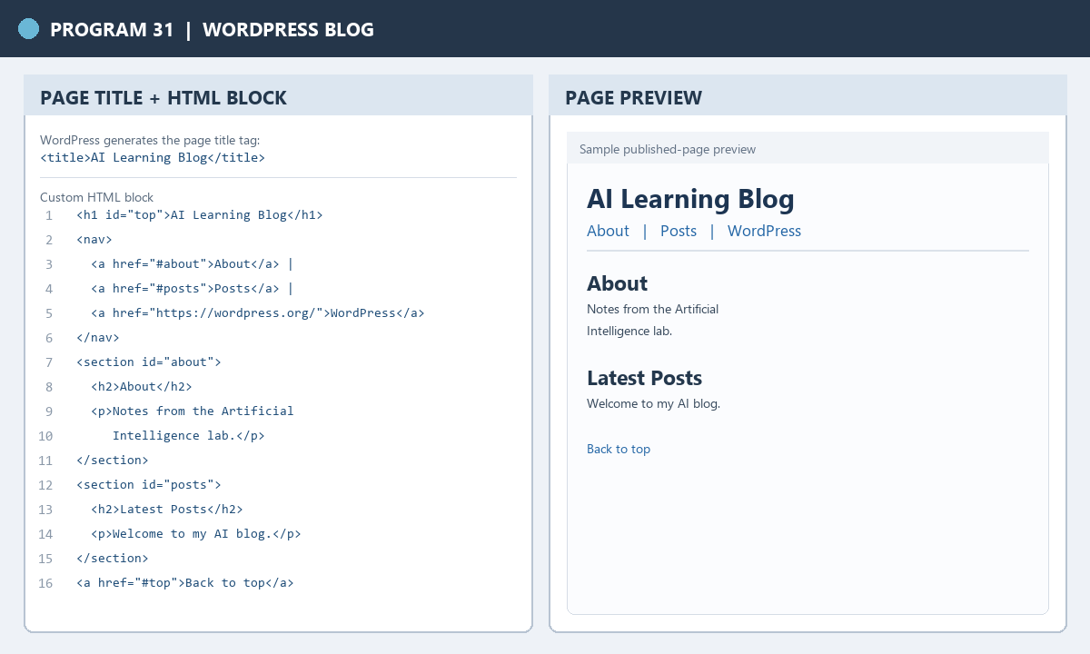
RESULT
Thus, the WordPress blog page demonstrates a page title, HTML anchor links, and navigation between sections.

CSA1708-ARTIFICIAL INTELLIGENCE
LAB EXPERIMENTS
Program 32 : Prolog Program to Implement Pattern Matching
Aim
To demonstrate Prolog pattern matching by unifying a pattern with a data structure.
Algorithm
1. Define a predicate that unifies a pattern with a data term.
2. Query it with a pattern containing variables.
3. Read the values bound to the variables; a mismatch fails.
Program
pattern_match(Pattern, Data) :-
Pattern = Data.
Sample Input
?- pattern_match(student(Id, Name), student(101, priya)).
?- pattern_match(student(101, _), student(102, rahul)).
Program Execution
?- pattern_match(student(Id, Name), student(101, priya)).
Id = 101,
Name = priya.
?- pattern_match(student(101, _), student(102, rahul)).
false.
Program 32 source and sample output
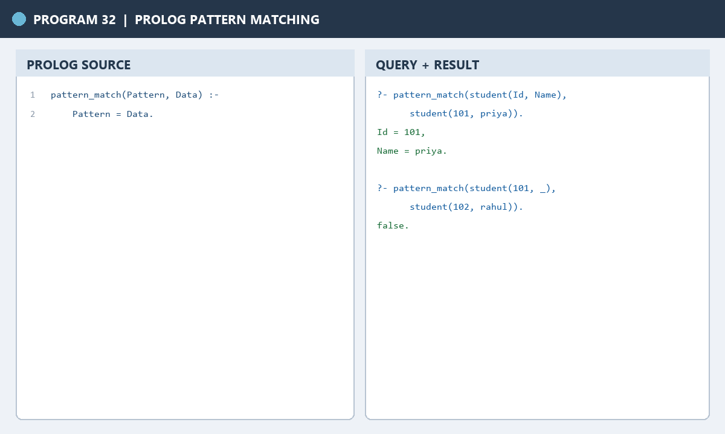
RESULT
Thus, pattern matching succeeds when the terms unify and fails when their fixed values differ.

CSA1708-ARTIFICIAL INTELLIGENCE
LAB EXPERIMENTS
Program 33 : Prolog Program to Find the Number of Vowels
Aim
To count the vowels in a lowercase string using Prolog recursion.
Algorithm
1. Define the five lowercase vowels as facts.
2. Return zero for an empty character list.
3. For each character, add one if it is a vowel; otherwise keep the count unchanged.
4. Convert the sample string to characters and query the counting predicate.
Program
vowel(a).
vowel(e).
vowel(i).
vowel(o).
vowel(u).

count_vowels([], 0).
count_vowels([H|T], Count) :-
vowel(H), !,
count_vowels(T, Rest),
Count is Rest + 1.
count_vowels([_|T], Count) :-
count_vowels(T, Count).
Sample Input
?- string_chars("artificial intelligence", Chars), count_vowels(Chars, Count).
Program Execution
Count = 10.
Program 33 source and sample output
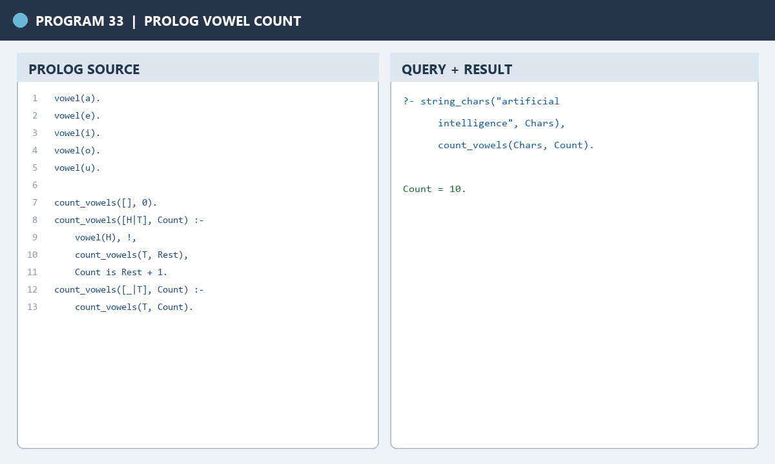
RESULT
Thus, the Prolog program counts and displays the number of vowels in the given string.

